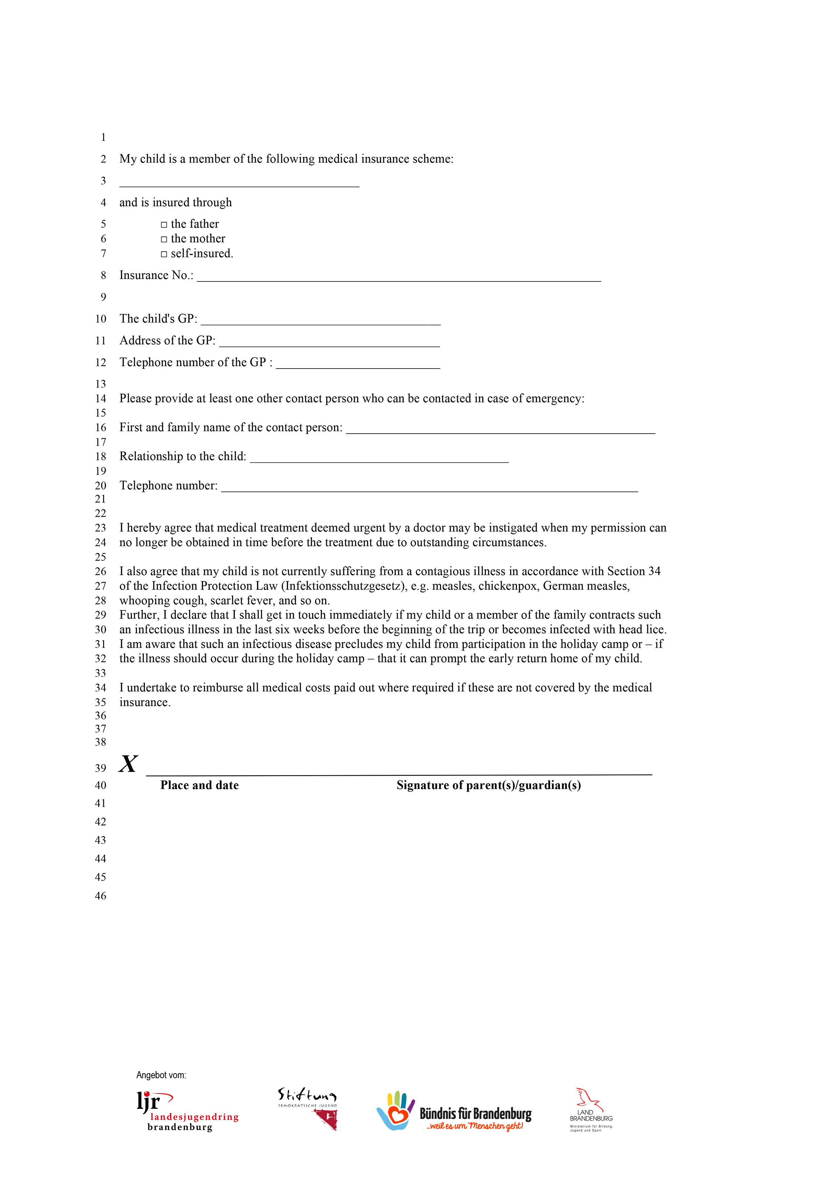
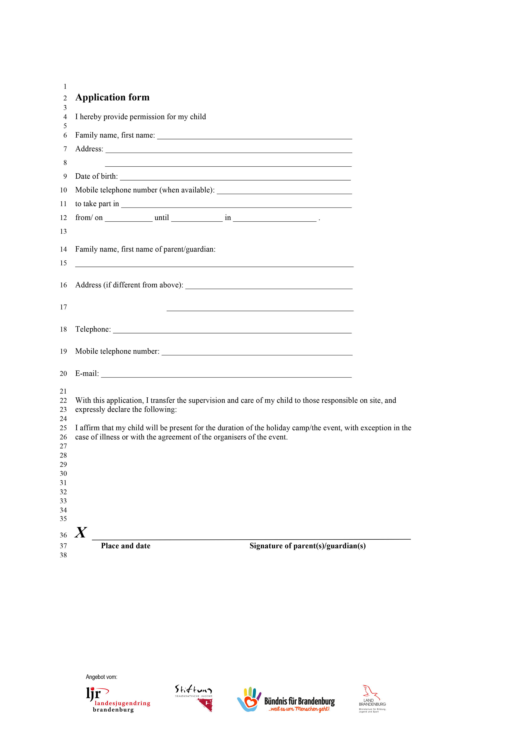
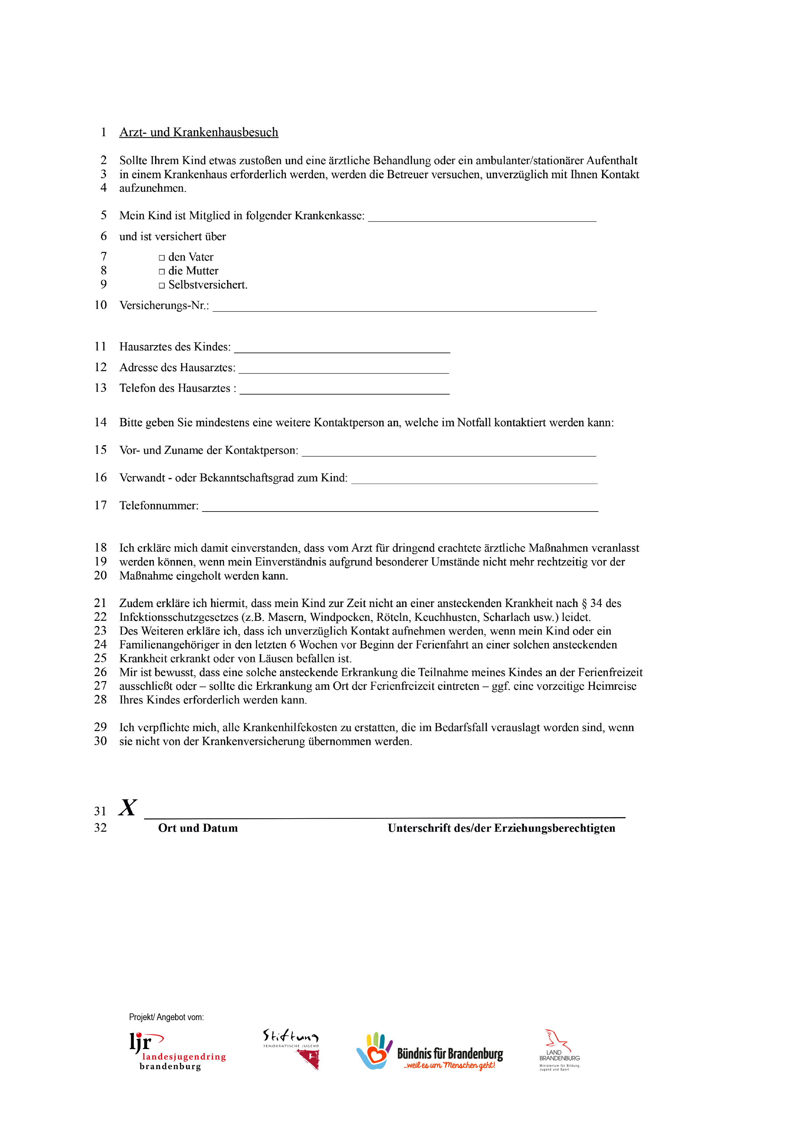
,

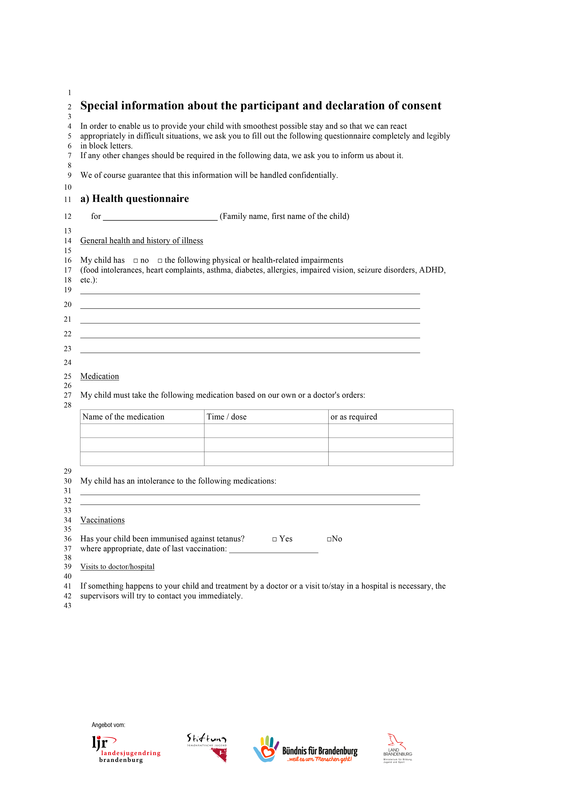
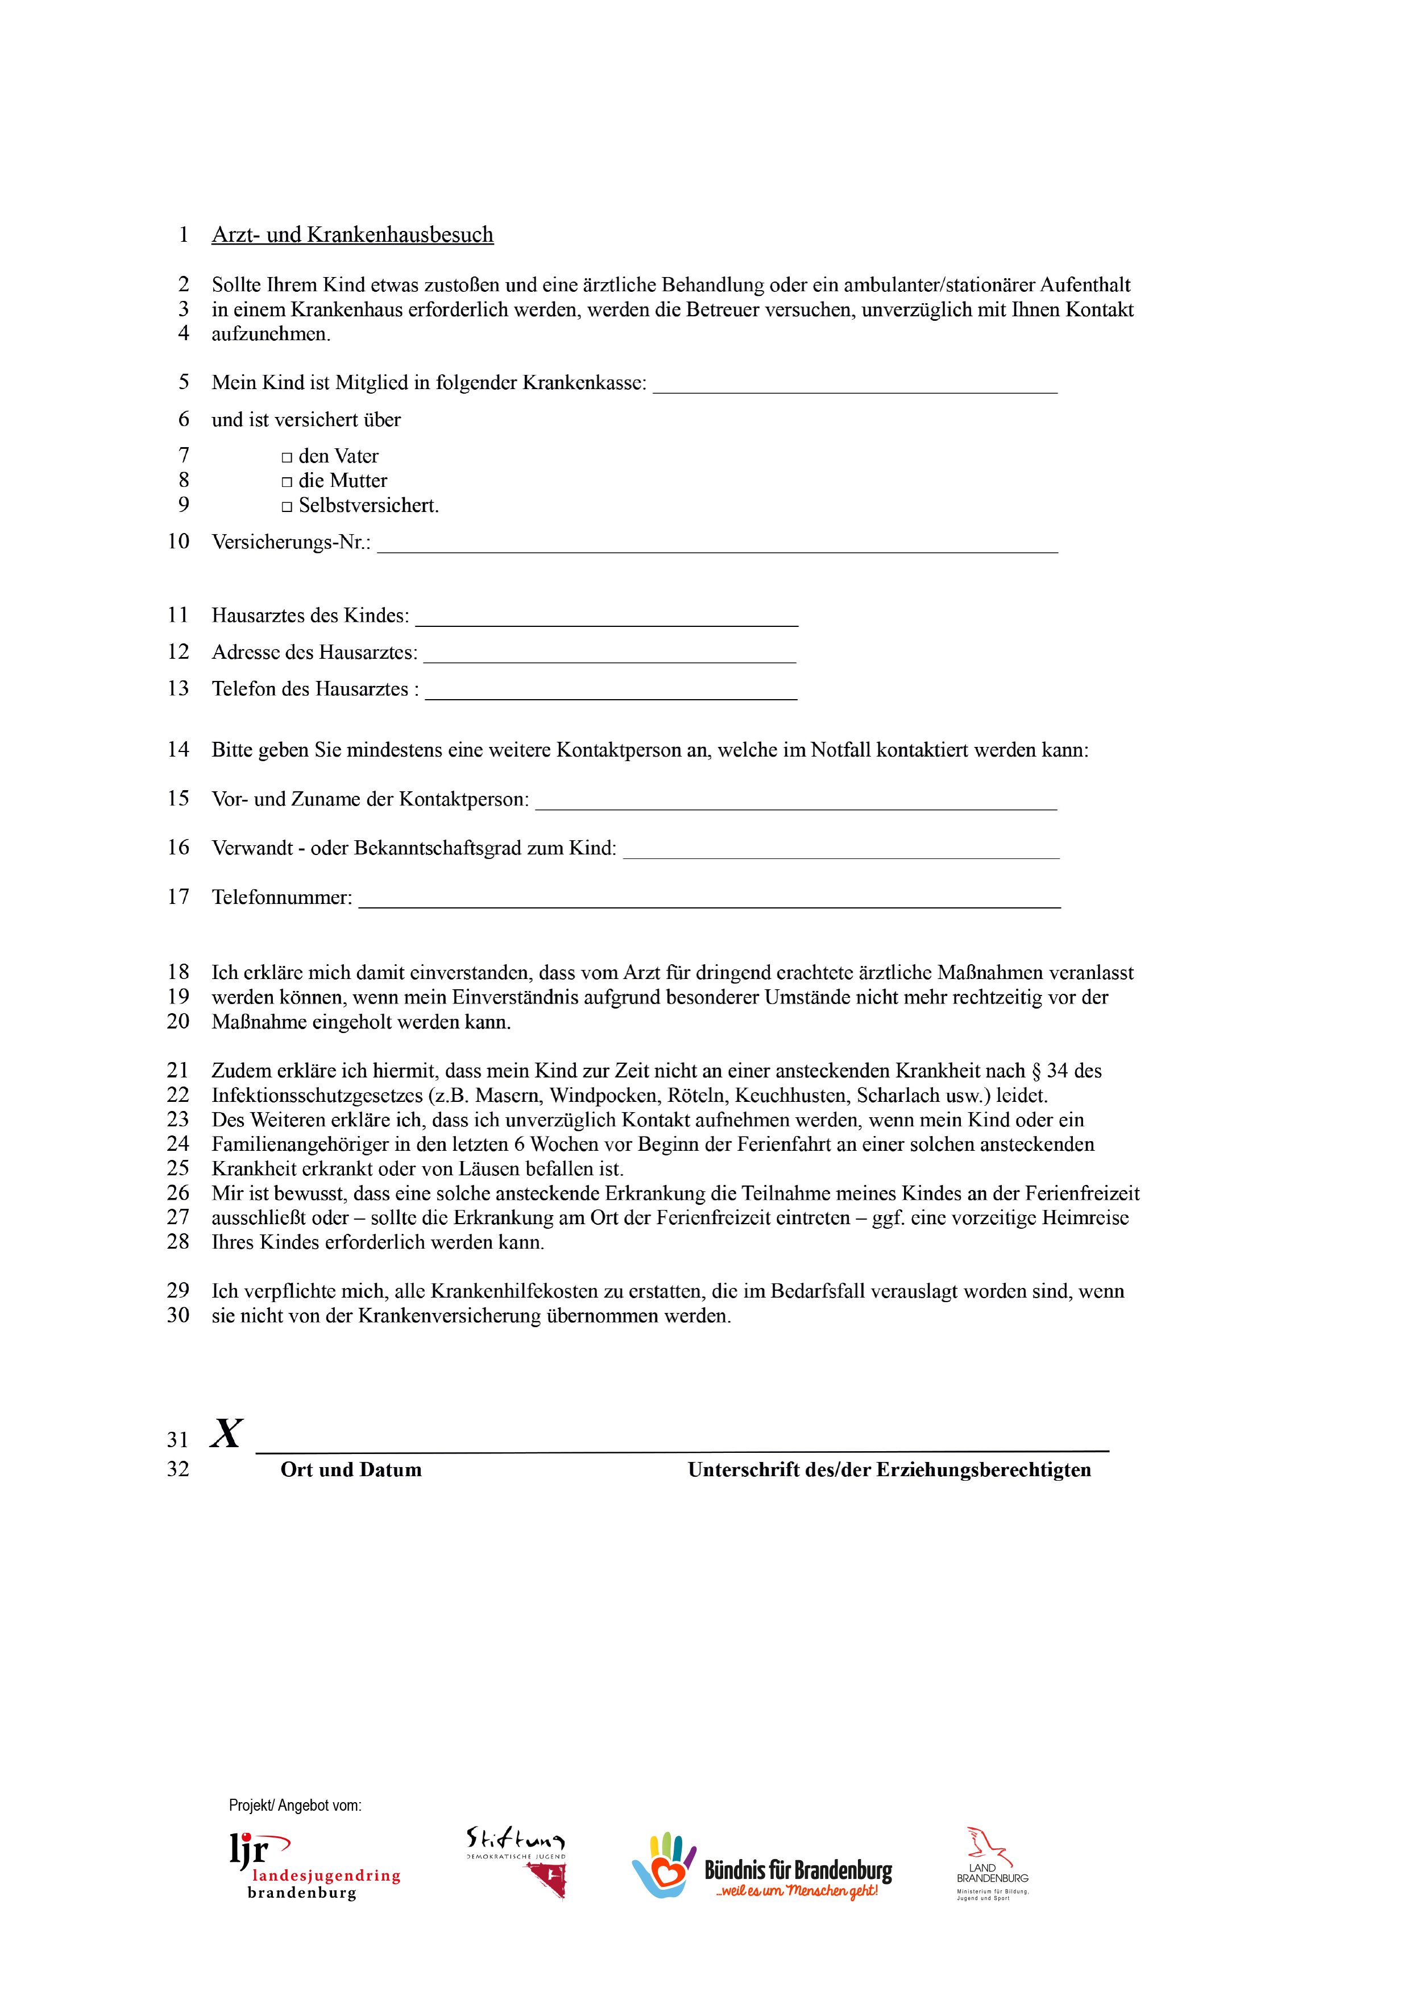

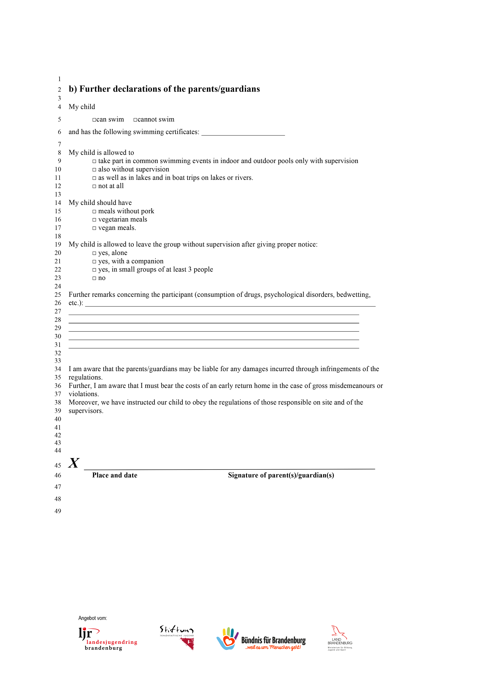

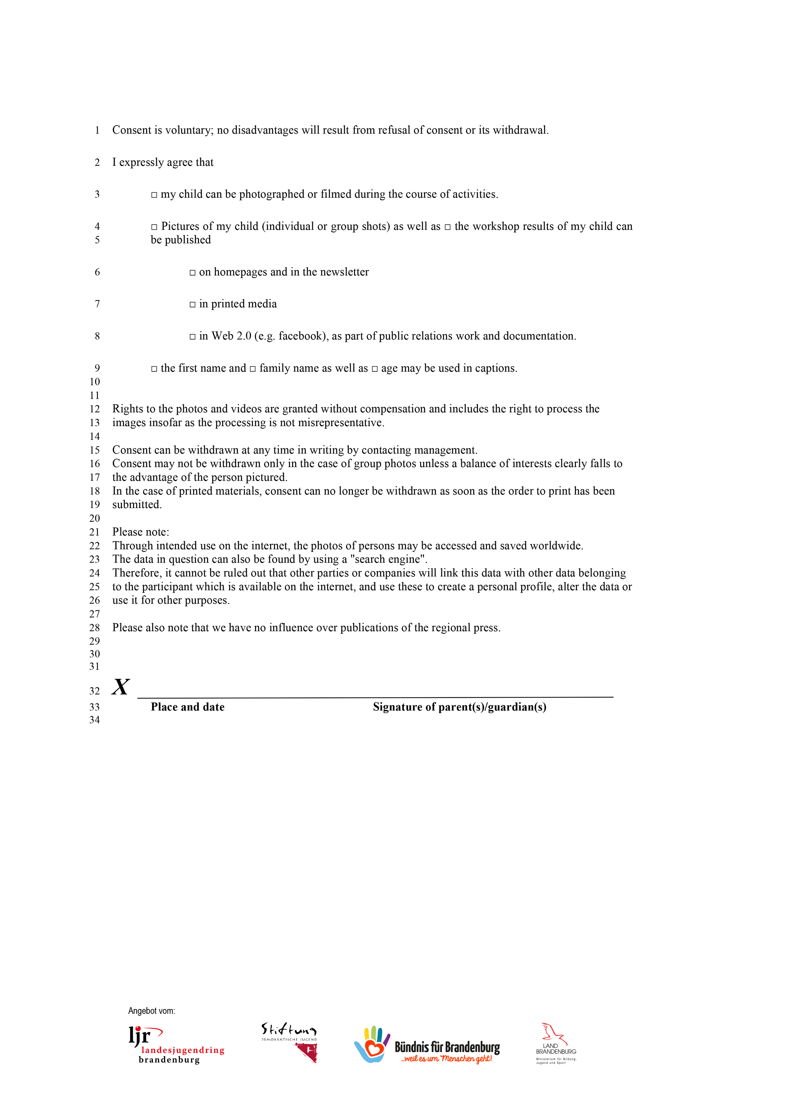

Data privacy policy with respect to the production and use of photo and/or video recordings in accordance with Art. 13 of the General Data Protection Regulation (GDPR)
- Name and contact details of the Controller:
Responsible for the data processing (Controller) is
Name of the organisation:
Contact person:
Address:
Telephone number:
Email:

- Purpose of the processing:
The photos and/or videos are intended exclusively for the public relations work of the above-mentioned organisation.
- Legal basis for the processing:
The photos and/or videos (collection, storage and disclosure to third parties (see Section 5)) are processed on the basis of the express consent of the legal guardian and/or the data subject, thus in accordance with Art. 6 Par. 1a GDPR. The publication of selected image files in (print) publications of the organiser as well as on their homepage/Facebook account, etc. is necessary for the public relations work of the organiser and serves the legitimate interests of the parties, in accordance with Art. 6 Par. 1f GDPR.
- Categories of recipients of the personal data:
The photos and/or videos will not be passed on to third parties. They will be published, where appropriate, on the homepage of the above-mentioned organisation and used for the Facebook page and other social media platforms of the above-mentioned institution for the purposes of public relations work.
- Duration of storage of the personal data:
Photos and/or videos that are made for the purposes of public relations work for the above-mentioned organisation will be stored for an indefinite period for the specific purpose, subject to the revocation of consent by the data subject.
- Right of revocation of consent:
Consent granted for the processing of the photos and/or videos can be revoked at any time with future effect. The lawfulness of consent-based data processing carried out until revocation is not affected.
- Rights of the data subject:
In accordance with the GDPR, you are entitled to the following rights:
- If your personal data is processed, you have the right to information on the data stored about your person. (Art. 15 GDPR)
- If inaccurate personal data is being processed, you have the right to correction (Art. 16 GDPR)
- Provided the statutory requirements are fulfilled, you can demand deletion or limitation of processing, or appeal against the processing (Art. 17, 18, 21 GDPR)
- If you have granted consent for the processing or a contract for the data processing exists and the data processing is carried out using automated procedures, you may have the right to data portability. (Art. 20 GDPR)
If you wish to exercise the above rights, the Controller will check that the statutory requirements for this exist. You also have the right to appeal to the Data Protection Officer for the State of Brandenburg.

